LAB-15: AMAZON Elastic Beanstalk

>search for elastic beanstalk.

Click on create application.

The application name – demoapp_march14.

Go down in environment information

Domain = demoapp31399. And click on check availability.

Go to platform and select python.

No change from next.

Click on next.

The service role is -> create and use new service role.

Key pair – keypairfeb28.

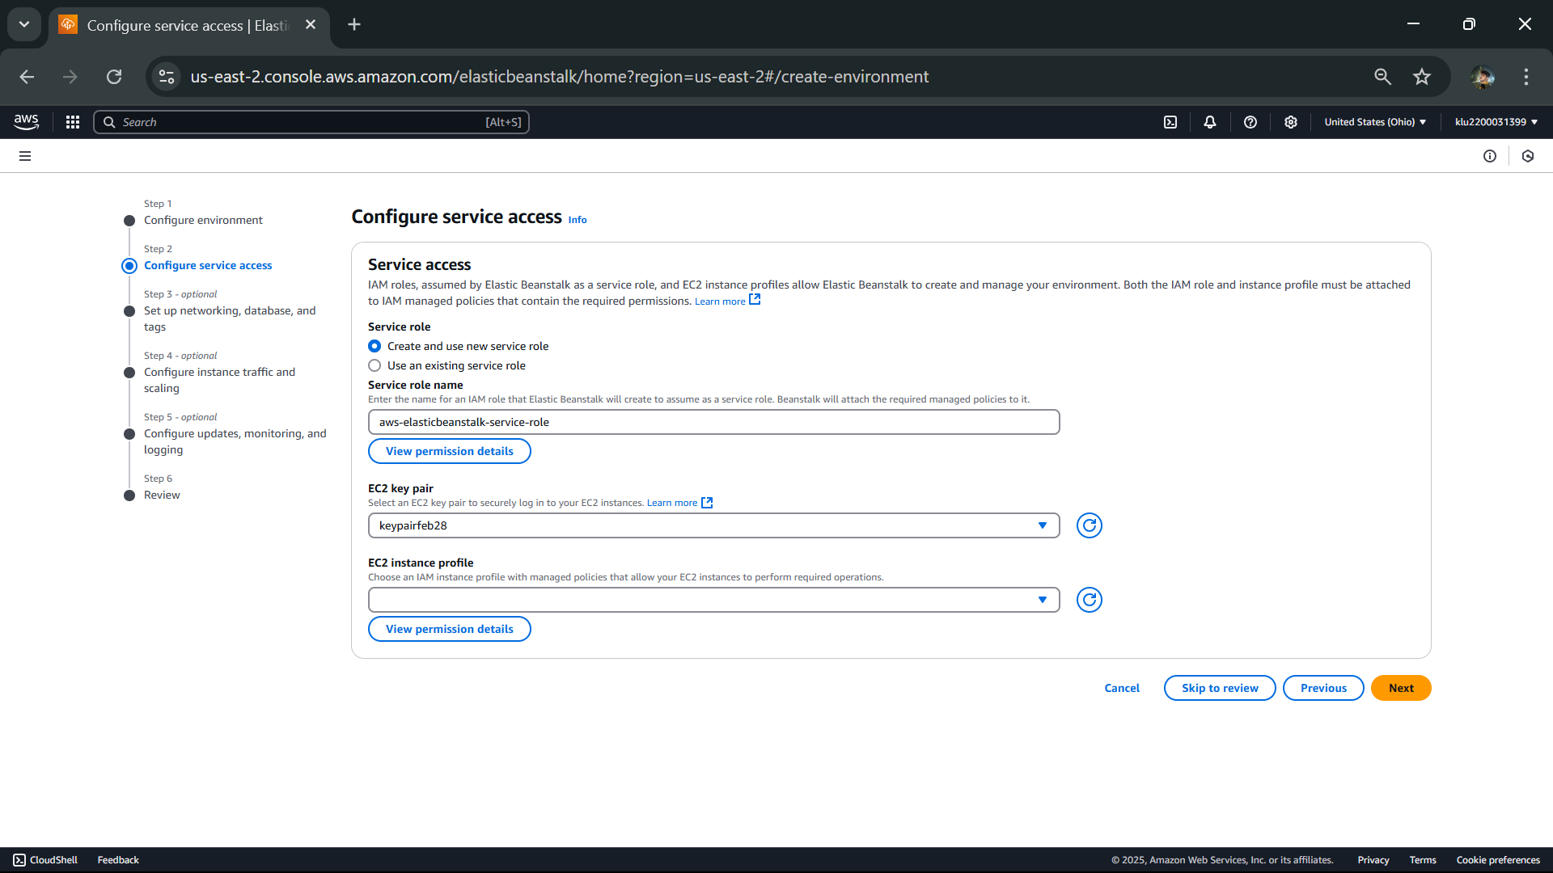

Click next.

Click on vpc that is given and follow the image.

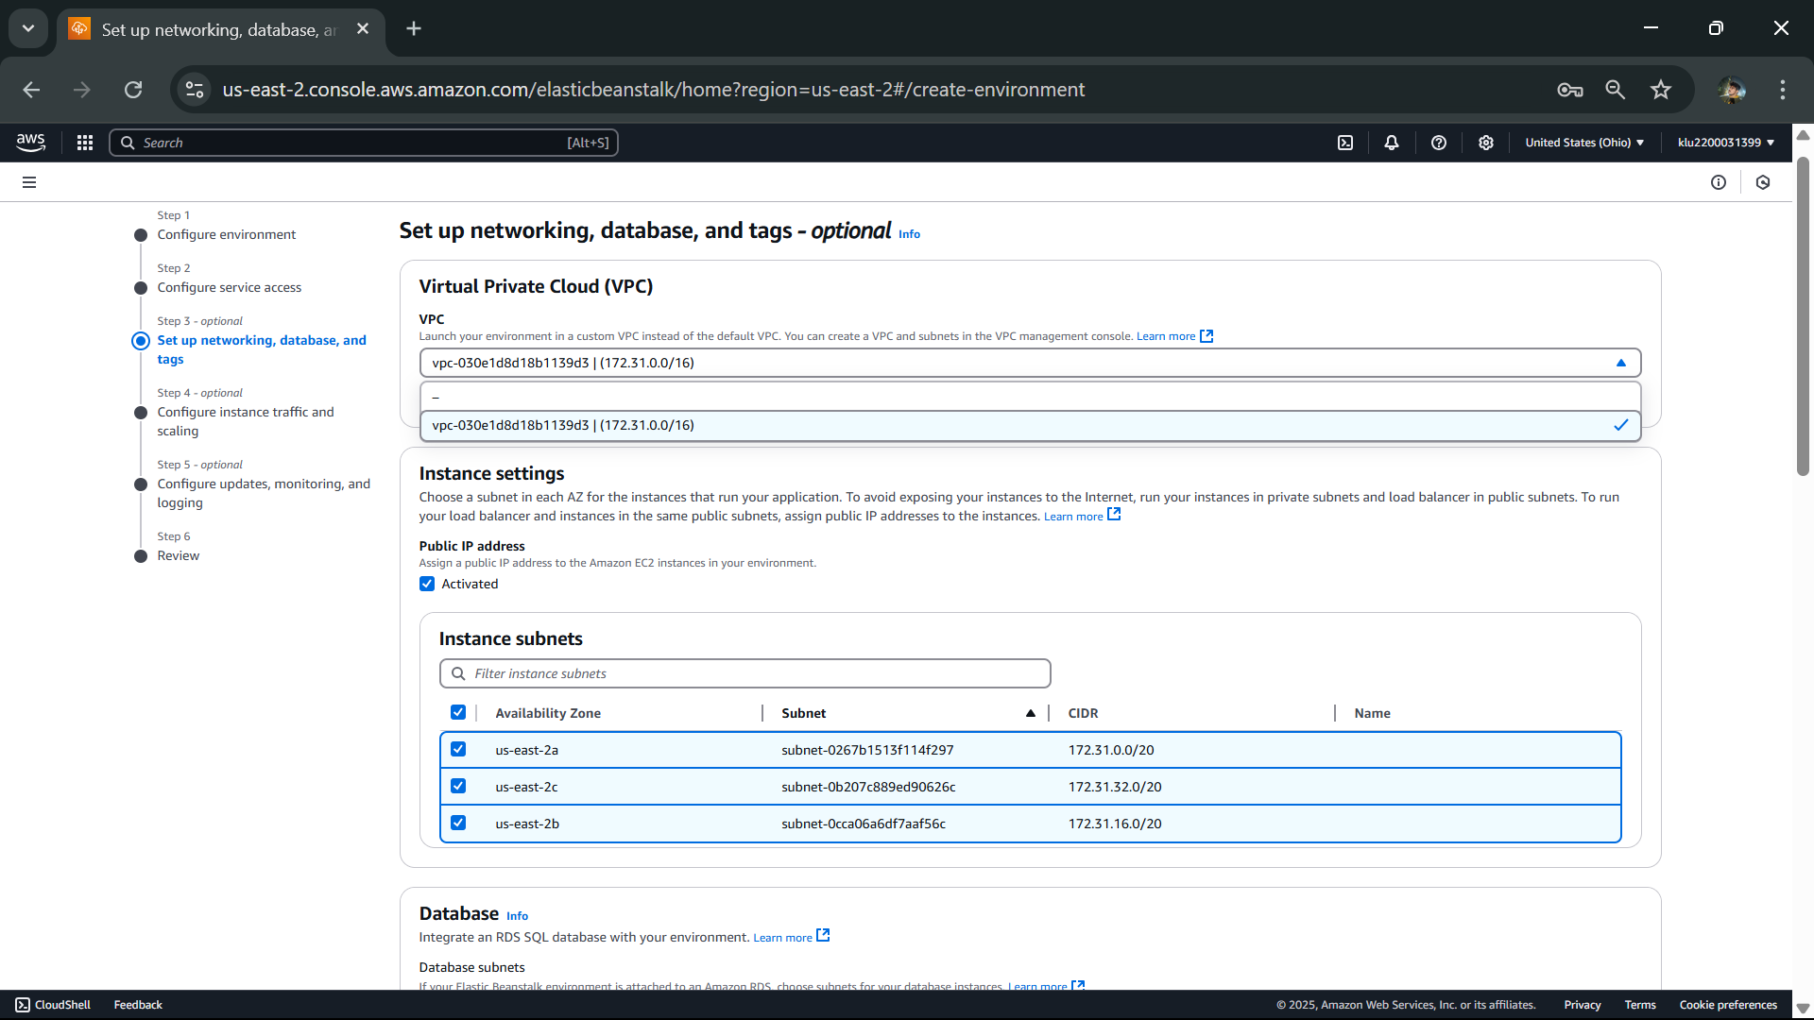

Click next.

No change direct go to review by clicking next.

Click on submit.

Just delete it.

